Germoe Parish Council

www.germoeparishcouncil.org.uk

July 30, 2026

To all Parish Councillors

Members of the Public

and Press

D Rutherford

Clerk to the Council
Germoe

telephone 07872 862232
email: GermoeParishClerk@hotmail.com

telephone 01326 221648

You are hereby summonsed to attend the Annual Meeting of Germoe Parish Council in Balwest Methodist Schoolroom on Thursday May 2, 2024. This will immediately follow the Annual Parish Meeting and will be for the purpose of transacting the following business.

AGENDA

1 ELECTION OF CHAIRMAN

2 chairman’s declaration of acceptance of office

3 APOLOGIES FOR ABSENCE

4 Declarations of Interest
- in items on the agenda
- of gifts (received as a result of being a member of the Council) of a value greater
than £50.00

5 CONFIRMATION OF THE MINUTES OF THE LAST MEETING

6 MATTERS ARISING AND NOT COVERED IN THIS AGENDA
It should be noted that no decisions may be made under this heading

7 PUBLIC PARTICIPATION

8 CORNWALL COUNCILLOR’S COMMENTS
CCllr J Keeling has circulated a report, updating us on key points discussed at The Cornwall Council meeting on the 16th April

- The admission of children to hospitals for surgery to remove rotten teeth as jumped up by 17% over the last year and there were more than 31,000 hospital operations last year to remove rotten teeth from children and teenagers. We do all we can to reduce tooth decay in children and Government should invest in oral health improvement programmes. Local councils can make a big difference in this matter by increasing awareness of dental hygiene with central government launching a dental recovery plan.

- The other motion was about the continued use of good quality agricultural land being used for solar panels. A very emotive subject but one that is being taken very seriously to prevent the best parcels of land being used. The question really was food and/or electricity and more innovative ways of combining both to find a solution. There was the usual heated debates about changes to the constitution but common sensed prevailed in the end.

On other issues CCllr Keeling is dealing with all sorts of traffic issues and complaints about the cones and fences left behind on the A394 following work. He is working hard to reassure people that there is still a lot more work planned for the A394 and we cannot keep putting traffic lights up every time and subsequently close the main Helston to Penzance arterial route

9 Election of vice-chairman

10 Standing orders
To re-adopt Germoe Parish Council’s Standing Orders (last substantially revised in June 2018)

11 FINANCIAL REGULATIONS
To re-adopt Germoe Parish Council’s Financial Regulations (last substantially revised in October 2018)

12 RISK DOCUMENT
To re-adopt Germoe Parish Council’s Risk Assessment Document (last reviewed in June 2021)

13 ELECTION OF COUNCILLORS TO POSTS OF RESPONSIBILITY
- Bank signatories
- Financial Scrutineer
- Notice-boards
- Footpaths and bridleways
- Planning
- Helston and the Lizard Community Area Partnership Meeting
- Germoe School
- Press Liaison
- Defibrillators

14 PARISH COUNCIL MATTERS
To appoint the Internal Auditor for the year to March 31, 2025

16 PARISH MATTERS

17 PLANNING
To make observations on planning applications including the following
Application PA24/02449 Proposal Application for Permission in Principle for construction of dwelling house and associated works. Location Land North East Of Wide Horizons Tresowes Hill Ashton Cornwall Applicant Mr And Mrs Buckett

18 GERMOE PARISH COUNCIL’S INSURANCE POLICY
To review the terms of Germoe Parish Council’s Insurance Policy and to consider an invitation from Clear Insurance Management Ltd to purchase insurance cover with Aviva through the firm in the sum of £380.55 (was £368.92 2023-2024).

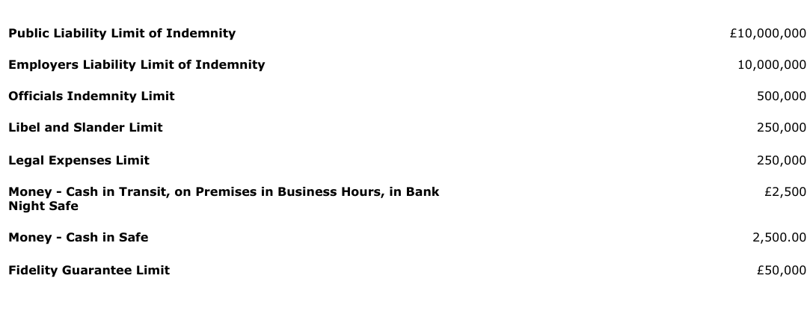

19 FINANCE

To note the internal auditor’s annual report on Germoe Parish Council’s financial statements for the year April 1, 2023 to March 31, 2024

Members to declare all conflicts of interest with BDO LLP (the external auditors).

To approve the Statement of Assurance

To receive the accounts for the year April 1, 2023 – March 31, 2024

To consider a resolution that Germoe Parish Council, having a turnover for the year 2023 – 2024 of less than £25,000 should declare that it is an exempt authority within the definition contained in the Local Audit (Smaller Authorities) Regulations 2015. (This means that the Internal Auditor’s report alone is sufficient for the Year’s accounts to be signed off. There is no requirement for a Limited Assurance Review to be undertaken.)

To Note

Payment was finally made via Payroll

Colin Chapman
Salary (April) 2639.71
HMRC 1052.53 TAX and Employer NIC

To approve payment of invoices received including the following

Gross vat

CFP Chapman Gratuity £ 288.33

D. Rutherford – Dec
Salary Hours 58:30 x £12.63 £ 736.32
Telephone £ 10.00
Stationary £ 14.98
Home Office £ 20.00

Total £ 781.30

20 REPORT OF CLERK AND CORRESPONDENCE

21 MEMBERS’ QUESTIONS

22 CHAIRMAN’S COMMENTS

23 MATTERS FOR INCLUSION AT FUTURE MEETINGS

DATE AND TIME OF NEXT MEETING
Thursday June 6, 2023 at 7.00pm in Balwest Methodist Schoolroom.

