Germoe Parish Council

www.germoeparishcouncil.org.uk

July 31, 2026

To all Parish Councillors

Members of the Public
and Press

D Rutherford

Clerk to the Council
Germoe

telephone 07872 862232
email: GermoeParishClerk@hotmail.com

You are hereby summonsed to attend the Annual Meeting of Germoe Parish Council Germoe Village Hall on Thursday May 15, 2025. This will immediately follow the Annual Parish Meeting and will be for the purpose of transacting the following business.

AGENDA

1. FIRE EVACUATION PROCEDURE
2. APOLOGIES FOR ABSENCE
a) To receive and accept apologies for absence
3. ELECTION OF CHAIRMAN
4. chairman’s declaration of acceptance of office
5. ELECTION OF VICE-CHAIRMAN FOR THE YEAR 2025/2026
6. TO RECEIVE MEMBERS DECLARATIONS OF ACCEPTANCE OF OFFICE
Declarations that have been received by and read out to the Clerk and countersigned by the Clerk
will be confirmed.
7. CO-OPTION NOTICE
a) To resolve to authorise the Clerk to advertise co-option vacancies for Germoe Parish Councillors
8. Declarations of Interest
- in items on the agenda
- of gifts (received as a result of being a member of the Council) of a value greater
than £50.00
9. CONFIRMATION OF THE MINUTES OF THE LAST MEETING
10. MATTERS ARISING AND NOT COVERED IN THIS AGENDA
It should be noted that no decisions may be made under this heading
11. PUBLIC PARTICIPATION incl CORNWALL COUNCILLOR’S COMMENTS
12. Standing orders
To re-adopt Germoe Parish Council’s Standing Orders (last substantially revised in June 2018
13. FINANCIAL REGULATIONS
To re-adopt Germoe Parish Council’s Financial Regulations (last substantially revised in October 2018)
14. RISK DOCUMENT
To re-adopt Germoe Parish Council’s Risk Assessment Document (last reviewed in June 2024)
15. ELECTION OF COUNCILLORS TO POSTS OF RESPONSIBILITY
- Bank signatories
- Financial Scrutineer
- Notice-boards
- Footpaths and bridleways
- Planning
- Community Area Partnership (CAP) Meeting
- Germoe School
- Press Liaison
- Defibrillators
- Standing Orders
- Financial Regulations
- Risk Document

16. PARISH COUNCIL MATTERS
17. PARISH MATTERS
18. PLANNING
To make observations on planning applications including the following

19. GERMOE PARISH COUNCIL’S INSURANCE POLICY
To review the terms of Germoe Parish Council’s Insurance Policy and to consider an invitation from Clear Insurance Management Ltd to purchase insurance cover with Ecclesiastical Insurance Office plc through the firm in the sum of £518.13

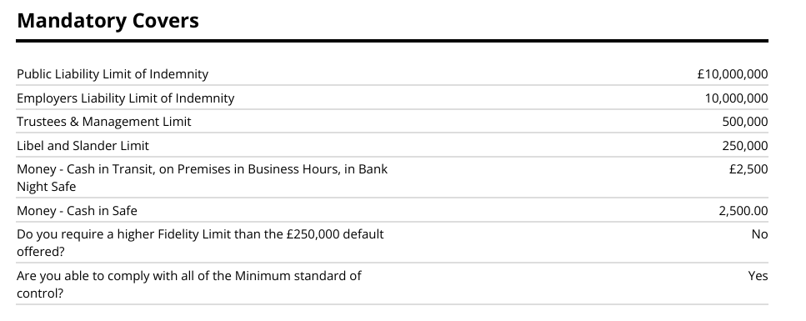
20. FINANCE

To note the internal auditor’s annual report on Germoe Parish Council’s financial statements for the year April 1, 2024 to March 31, 2025.

Members to declare all conflicts of interest with BDO LLP (the external auditors).

To approve the Statement of Assurance

To receive the accounts for the year April 1, 2024 – March 31, 2025

To consider a resolution that Germoe Parish Council, having a turnover for the year 2024 – 2025 of less than £25,000 should declare that it is an exempt authority within the definition contained in the Local Audit (Smaller Authorities) Regulations 2015. (This means that the Internal Auditor’s report alone is sufficient for the Year’s accounts to be signed off. There is no requirement for a Limited Assurance Review to be undertaken.)

To approve payment of invoices received including the following

Gross Net vat

R Sanders – Cuts 1/4 and 16/4 £ 264.00 £ 220.00 £44.00

B. Goraus (Internal Audit) £ 160.00

D. Rutherford – April
Salary Hours 45 x £13.26 £ 596.70
Telephone £ 10.00
Stationary £
Home Office £ 20.00

Total £ 626.70

21. REPORT OF CLERK AND CORRESPONDENCE
22. MEMBERS’ QUESTIONS
23. CHAIRMAN’S COMMENTS
24. MATTERS FOR INCLUSION AT FUTURE MEETINGS

DATE AND TIME OF NEXT MEETING
Thursday June 5 2025 at 7.00pm in Germoe Village Hall.

